Web task

ahmed nour :with navbar and without green button
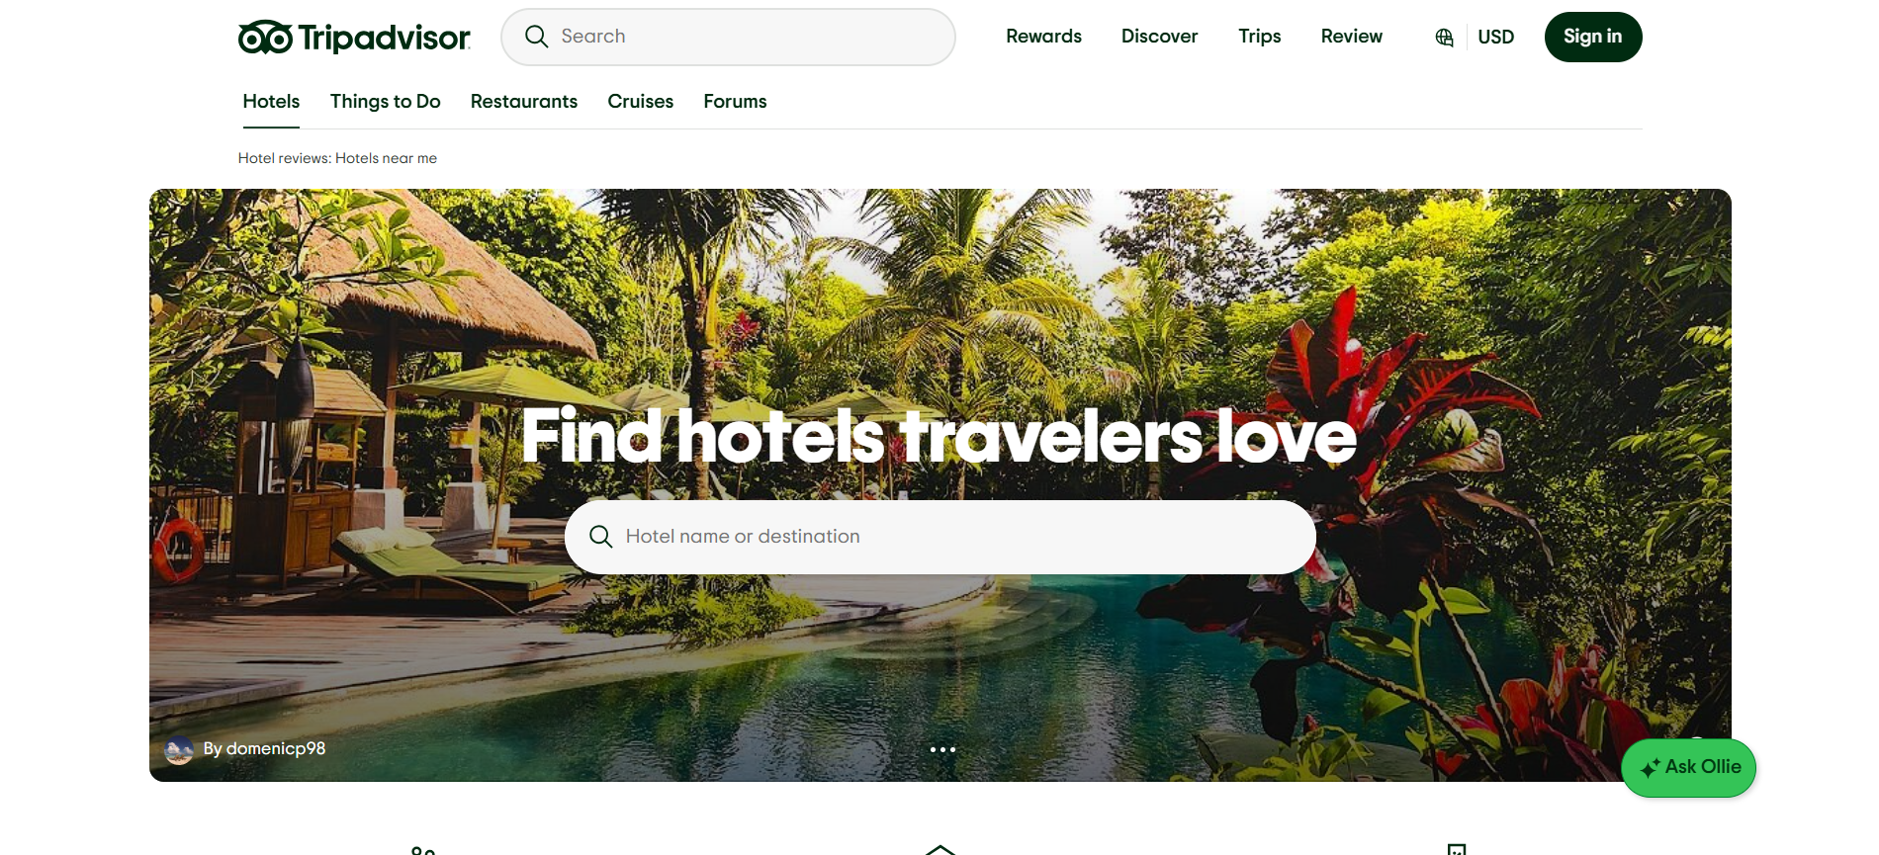

Rodina : without green button
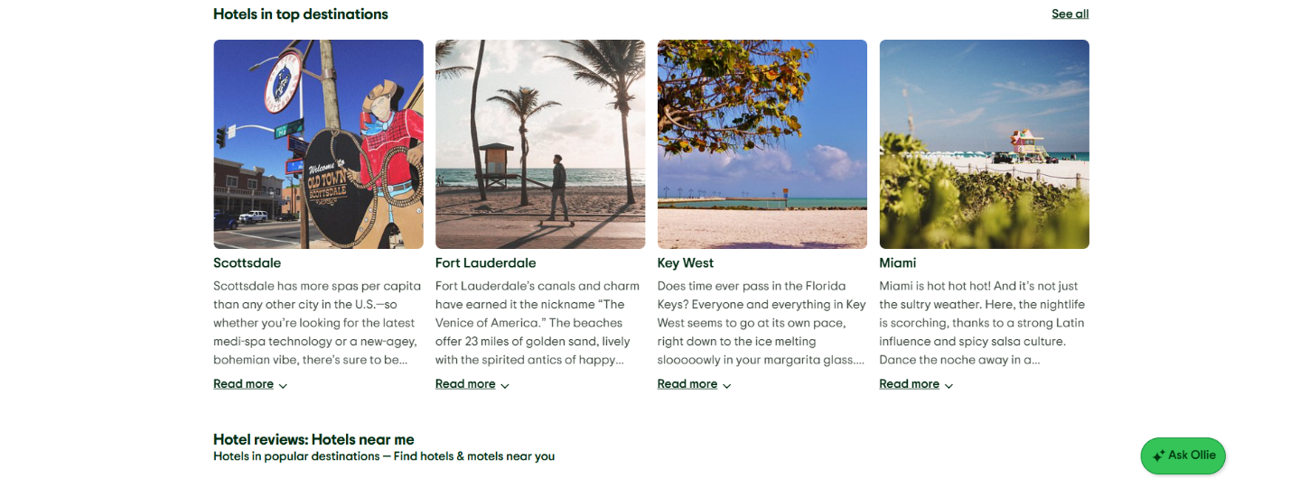

Mohaned : without green button

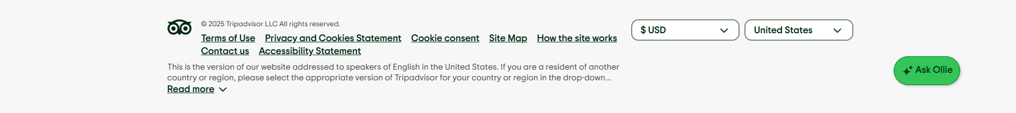

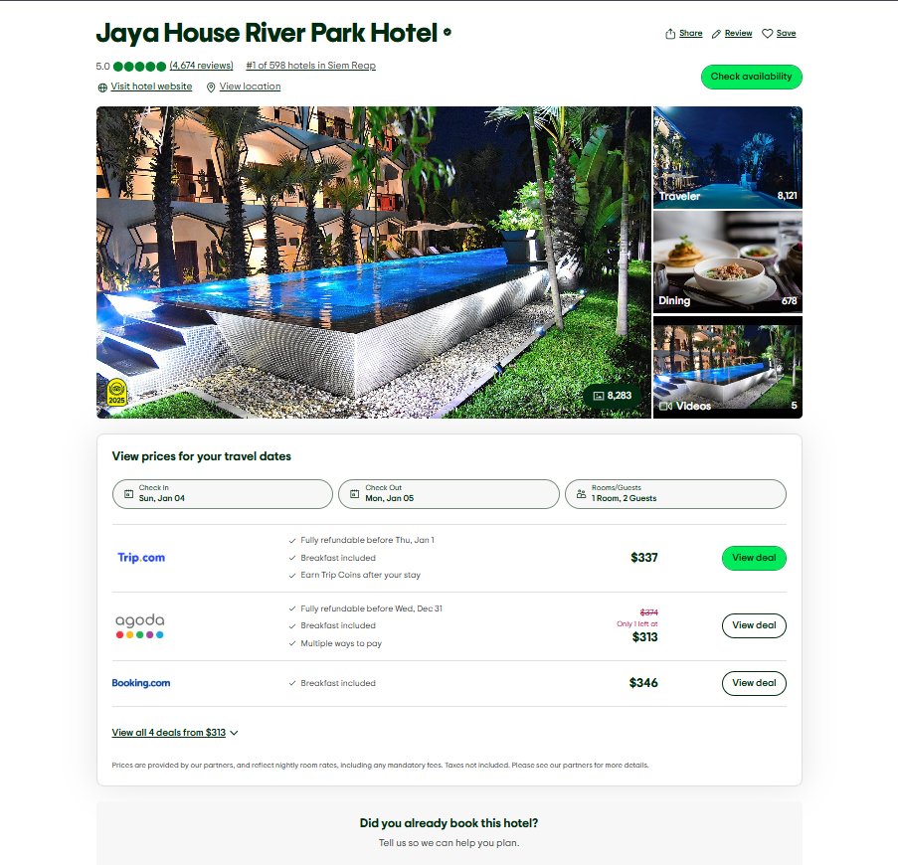
Youssef:

Hager:
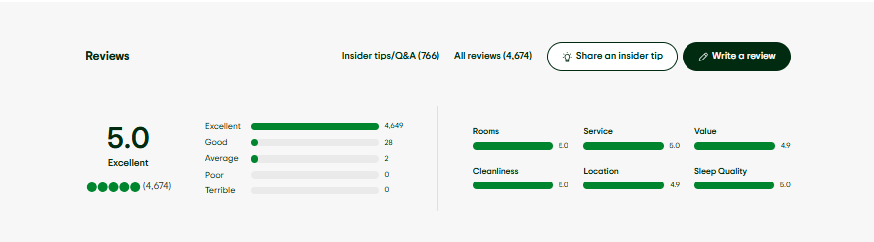

Abdo: make a payment form

